Adolescent Mental Health: A Community Intervention Perspective

UNAM Europe Research Seminar with Ulysseus

Mexico Pavilion, University of Seville
May 7–8



Agenda
May 7
09:00–09:30 | Registration and online connection via Microsoft Teams
09:30–10:00 | Opening Session

Session 1. Global and Local Challenges in Youth Mental Health
Time: 10:00–11:30
María Elena Medina-Mora Icaza, National Autonomous University of Mexico (UNAM): Addictions and Youth Mental Health.
Benedicto Crespo-Facorro, University of Seville: Beyond Simplifications: Understanding and Addressing Adolescent Suicide.
Marie Rose Moro, University of Paris City: The “Adolescent House” Concept in France, Mexico, and Worldwide.
María del Carmen Moreno, University of Seville: Emotional Well-being of Adolescents in Spain: Reflections on Gender Socialization and Its Consequences.

11:30–11:45 | Coffee Break

Session 2. Social Determinants, Gender, and School Environment in Adolescent and Youth Mental Health
Time: 11:45–13:15
Ángeles Cedillo & Agustín Luque Fernández, University of Seville: Health Promotion Strategies at the University of Seville.
Cossete Franco Muñoz, Pablo de Olavide University: Adolescent Mental Health: A Gender Perspective.
Ikram Benazizi Dahbi, Institute for Advanced Social Studies (CSIC, Córdoba): Mental Health and Well-being in Young Populations: A View from Social Inequalities and Structural Determinants.
Raffael Heiss, Management Center Innsbruck: Social Media and Youth Mental Health: Evidence, Challenges, and Policy Responses.

13:15–14:30 | Lunch

Session 3. Community Intervention Perspectives in the School Environment
Time: 14:30–16:00
Maaike Nauta, University of Groningen: Indicated Prevention for Anxiety Disorders in a School Setting.
Jacqueline Priego, University of Portsmouth: Supporting International Students Throughout Their Academic Journey: From Aspirations to Graduation and Beyond.
Kevin Rigaid, Université Côte d’Azur: Effective Interventions for Student Mental Health: Leveraging Mindfulness Beliefs and Self-Efficacy to Foster Resilience After Academic Setbacks.
Andrea González Rodríguez, UNAM: Community Health Services at the National Autonomous University of Mexico: A Strategy for the Student Population.

May 8

Internal meeting
Topic: Design of the Research and Intervention Framework on Adolescent and Youth Mental Health in School Settings
Time: 10:00–12:00
Participants: Speakers from May 7, along with directors of UNAM Spain offices in Europe and representatives of the Ulysseus Alliance at the University of Seville

Clossing sesion
Time: 12:00–12:15
Julián Martínez, Vice-Rector for International Relations, University of Seville
Ciro Murayama, Director of UNAM Spain

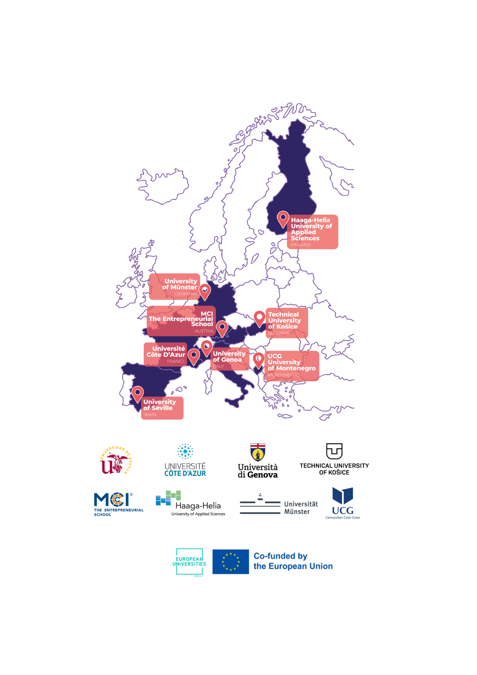

The Ulysseus Action has received funding from the European Union’s Erasmus + Programme under the grant agreement No 101124733. The views and opinions expressed in this communication are the sole responsibility of the authors and do not necessarily reflect the views of the European Commission

