Accommodation
To support your stay in Innsbruck, MCI collaborates with the Innsbruck Convention Bureau to provide participants of the Ulysseus MCI Week with a range of accommodation options across different hotel categories. We recommend you to book your preferred hotel directly via the provided Summit Booking Link:
Ulysseus MCI Summit Booking Link:
https://www.innsbruck.info/en/convention/conferences-and-congresses/mci-ulysseus-week-2026/quickfinder.html
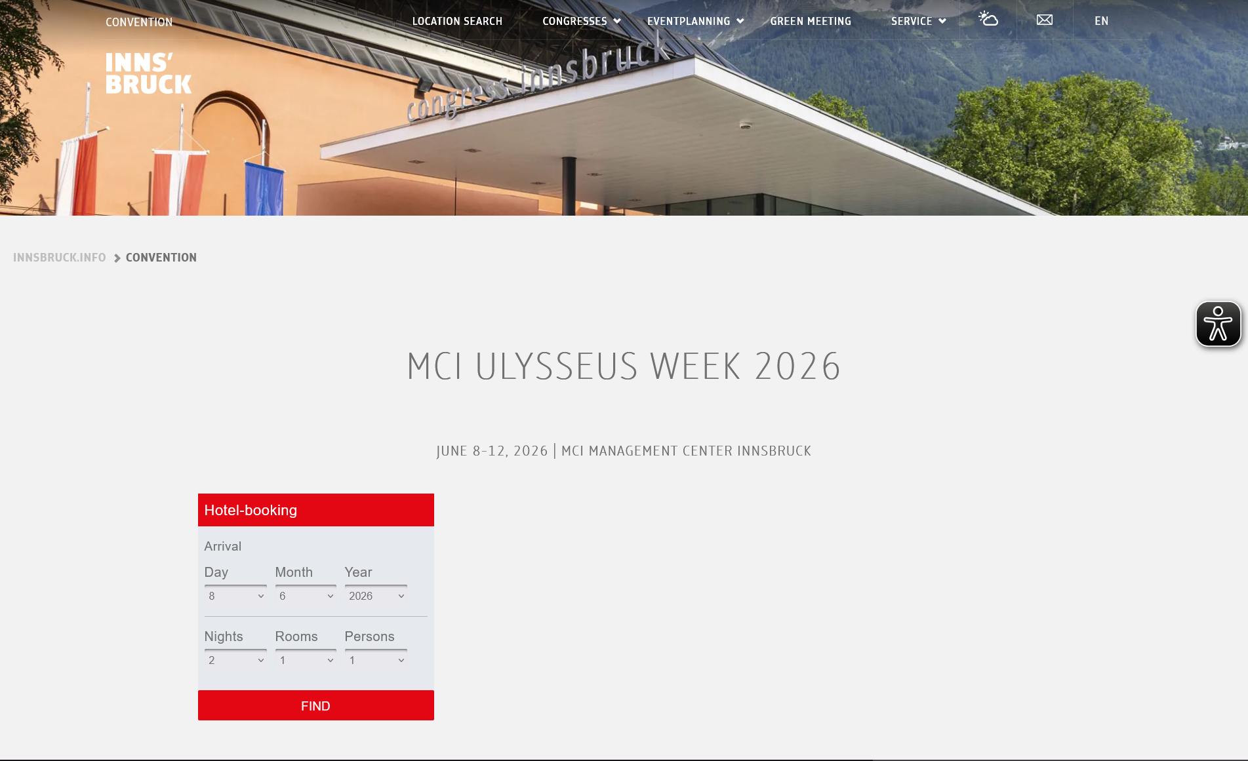
For individual requests or extensions of stay, participants are welcome to contact the Innsbruck Convention Bureau directly for booking requests:

Innsbruck Convention Bureau
T +43 512 53 56 9704
meeting@innsbruck.info
www.innsbruck.info/convention, www.innsbruck.info

Should the Ulysseus MCI Week & Summit booking link above not offer suitable options, MCI partners with additional selected hotels on a regular basis that may also provide preferential
When booking, please mention your affiliation with MCI and use the booking code “MCI Lecturer” when making your reservation.
Please note!. As Innsbruck is particularly very busy in June, early booking is strongly recommended. Any preferential rates are offered at the discretion of the respective hotels. MCI does not set, manage, or guarantee these rates, and they remain subject to change and availability.
MCI Partner Hotels
A list of MCI partner hotels is provided below..
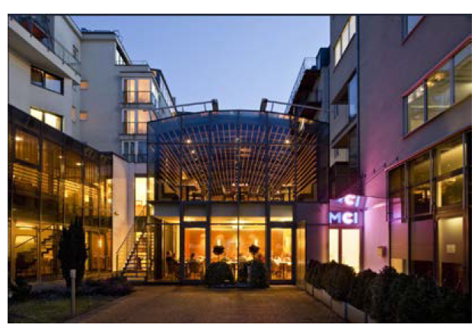
Hotel Grauer Bär
P: +43/(0)512 59 24-0
grauer-baer@innsbruck-hotels.at
Directions

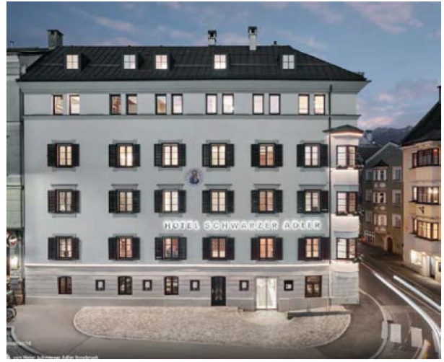
Hotel Schwarzer Adler
P: +43/(0)512 58 71 09
info@deradler.com
Directions

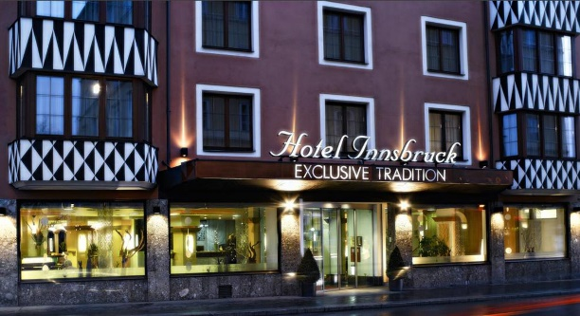
Hotel Das Innsbruck
P: +43/(0)512 598 68 93
office@hotelinnsbruck.com
Directions

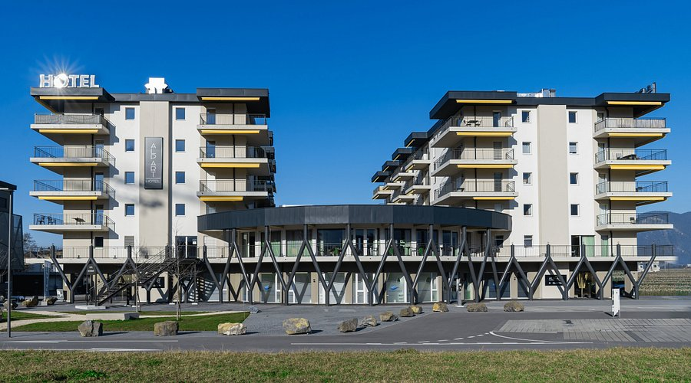
Alp Art Hotel
P: +43/(0)5234 48010
info@alparthotel.at
Directions

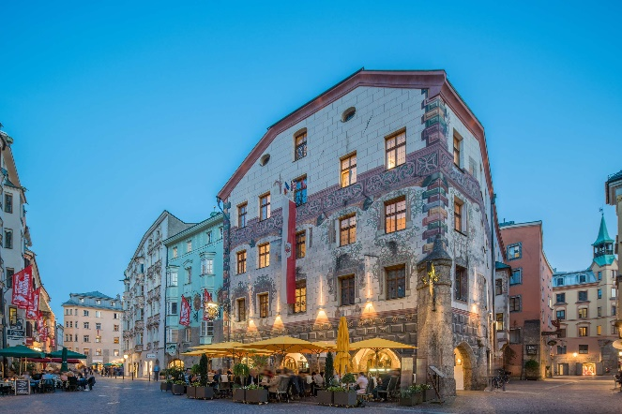
Hotel Goldener Adler
P: +43/(0)512 57 11 11 0
office@goldeneradler.com
Directions

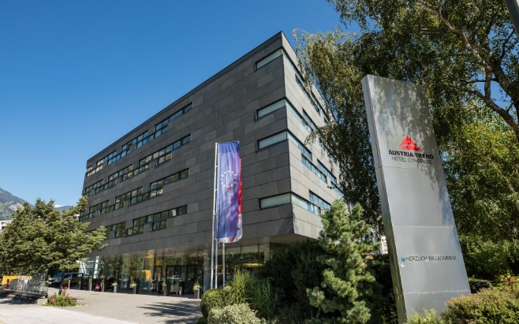
Austria Trend Hotel Congress
P: +43 (0)512 2115-0
congress@austria-trend.at
Directions

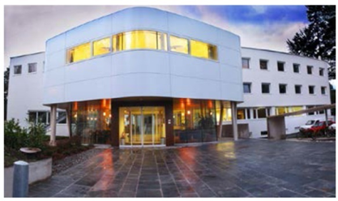
Haus der Begegnung
P: +43/(0)512 58 78 69
hdb.kurse@dibk.at
Directions

