
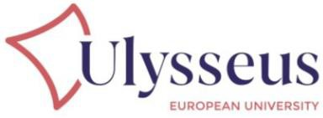
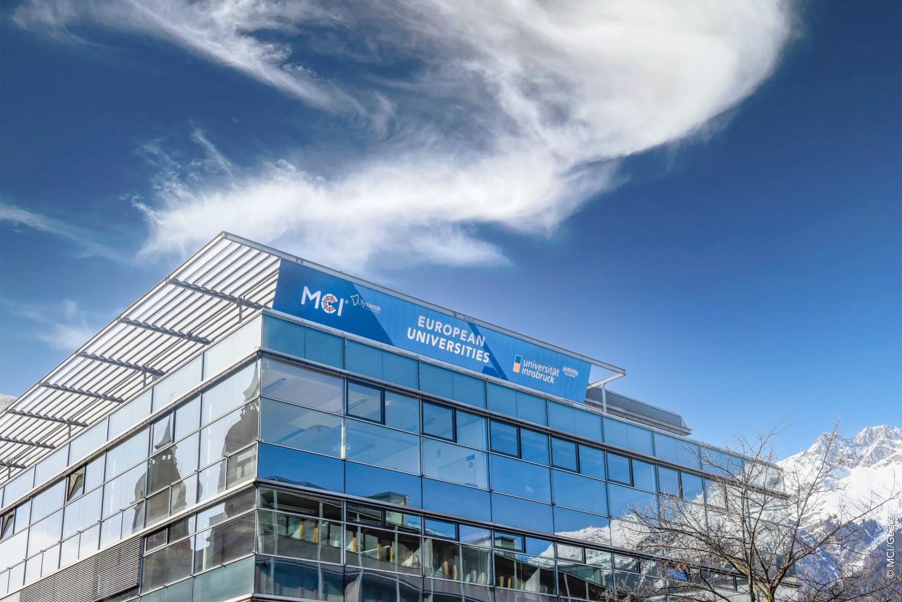

Ulysseus MCI Summit Preliminary
Program
Innsbruck | 11 & 12 June 2026
*program is subject to change

PRACTICAL INFORMATION

We are pleased to welcome you to the Ulysseus MCI Summit 2026 in Innsbruck, Austria.
The annual summit brings together colleagues from across the alliance to continue our joint work, exchange perspectives, and strengthen collaboration in a focused and engaging setting.
Located in the heart of the Alps, Innsbruck offers a unique combination of academic exchange, innovation, and accessibility. MCI | The Entrepreneurial School® looks forward to hosting you and supporting a productive and enjoyable event.
This document provides key practical information to support your planning, including travel guidance and accommodation.

Overview at a Glance
The Ulysseus Summit takes place on Thursday and Friday, featuring plenary sessions, work package meetings and excursions to Associated Partners. From Friday noon onwards, participants are warmly invited to join the celebrations of MCI’s 30th anniversary.

Thu, 11 June – Ulysseus SUMMIT
Plenary session, parallel working sessions, and Joint Summit Dinner

Fri, 12 June – Ulysseus SUMMIT & MCI 30th Anniversary
Governing Council meeting, working sessions, excursions, and MCI 30th anniversary programme

Ulysseus Summit in Innsbruck
- Registration link
- Program overview
THURSDAY, 11 JUNE 2026
Main Summit Day | Plenary & Parallel Sessions

08:30 – 09:00 Registration

09:00 – 10:30 Summit Plenary - PART I

The central strategic session of the Summit, bringing together all Ulysseus partners to review alliance-wide progress, assess key achievements across work packages, and align on priorities for the next phase.
10:30 – 11:00 Coffee Break

11:00 – 12:15 Summit Plenary - PART II
12:15 – 13:30 Group photo + Lunch Break
12:30 – 13:30 Parallel Working Lunches
Project Managers + Project Officers + Innovation Hub Managers

13:30 – 15:00 Parallel Sessions (parallel working sessions)

- WP1 - General Committee Meeting
- WP3 - Joint Masters Session

15:00 – 16:30 Parallel Sessions (parallel working sessions)

- WP3 – Joint PhD Session
- WP6 – Inclusion, Diversity & Capacity Building (Semi-Annual)
- WP1 - UlySA Session (Student Board)
- WP2 - Joint IPO–IHM Session

17:00 – 18:30 European Event (plenary session)

Panel discussion on the role of European Universities.

18:30 – 19:00 Networking Aperitif

Informal networking to connect participants across institutions, disciplines, and roles.

19:00 Joint Summit Dinner

Official summit dinner bringing together all Ulysseus participants in a relaxed setting to strengthen relationships and foster informal exchange.

FRIDAY, 12 JUNE 2026
Ulysseus | 30 years MCI celebrations

08:00 – 12:00 Excursions to Associated Partners

Curated visits to regional and institutional MCI and Ulysseus partners, offering insights into local ecosystems, applied research environments, and collaboration opportunities linked to Ulysseus InnoHub and activities.
09:00 – 10:30 Parallel Sessions (parallel working sessions)

- WP1 - Governing Council Meeting
- WP5 - Innovation Ecosystems & Territorial Engagement Meeting (Task 5.6)
- WP9 - Communication & Dissemination Lab

10:30 – 11:00 International Deans Reception

Informal reception for members of the Ulysseus Governing Council by invitation of the MCI Rector and International Office.
12:00 – 15:00 MCI 30 Years Anniversary Ceremony

Flagship celebration marking MCI’s 30-year anniversary with high level speakers, stakeholders and guests.
15:00 – 17:00 MCI 30 Years Alumni Program

17:00 – 18:00 MCI 30 Years Festive Symposium

Anniversary symposium with a high-level, internationally composed audience.

From 18:30 MCI 30 Years Closing Reception

Final networking event with all guests

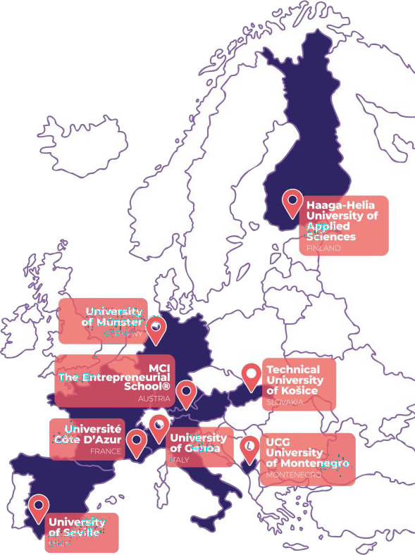
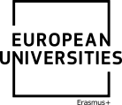


The Ulysseus Action has received funding from the European Union’s Erasmus + Programme under the grant agreement No 101124733. The views and opinions expressed in this communication are the sole responsibility of the authors and do not necessarily reflect the views of the European Commission.

