Applied Artificial Intelligence in Business and Education Innovation Hub Presentation



AI Innovation Hub Presentation
Draft Programme
Theme: AI in Business and Education
Wednesday 7.10. – Haaga-Helia Innovation Hub & AI in Practice
MORNING
09:00–09:30 | Registration & Coffee
09:30–9:45 | Welcome and Day Overview/Practicalities  Welcome to Helsinki & Haaga-Helia.
9:45–11:15 | Two Keynotes  (1) Human-Centered AI in Business · (2) AI in Education.
11:15–11:40 | The AI Innovation Hub – Achievements, Goals & Plans
11:40–12:00 | Vision of the InnoHub
12:00–13:15 | Lunch
AFTERNOON
13:15–14:15 | Panel – AI Transformation in Practice
14:15–16:00 | Innovation Hub Project Presentations & Marketplace
14:15-16:00 | AI Demo Corner (Runs simultaneously with Innovation Hub Project Presentations)
EVENING
19:00–22:00 | Networking Dinner
Thursday 8.10.– Helsinki AI & Innovation Ecosystem
MORNING
09:00–09:30 | Welcome Coffee
09:30–10:00 | Keynote: Building Regional AI Innovation Ecosystems
10:00–10:45 | Ulysseus AI Research Groups – Spotlight
10:45–11:15 | Coffee Break
11:15–12:15 | Collaboration in Action & Ecosystem Conversations
12:15–13:00 | Lunch
AFTERNOON
13:00-15:00 | Ecosystem Conversations & Startup Encounters
15:00–16:00 | Reflections & Closing Remarks

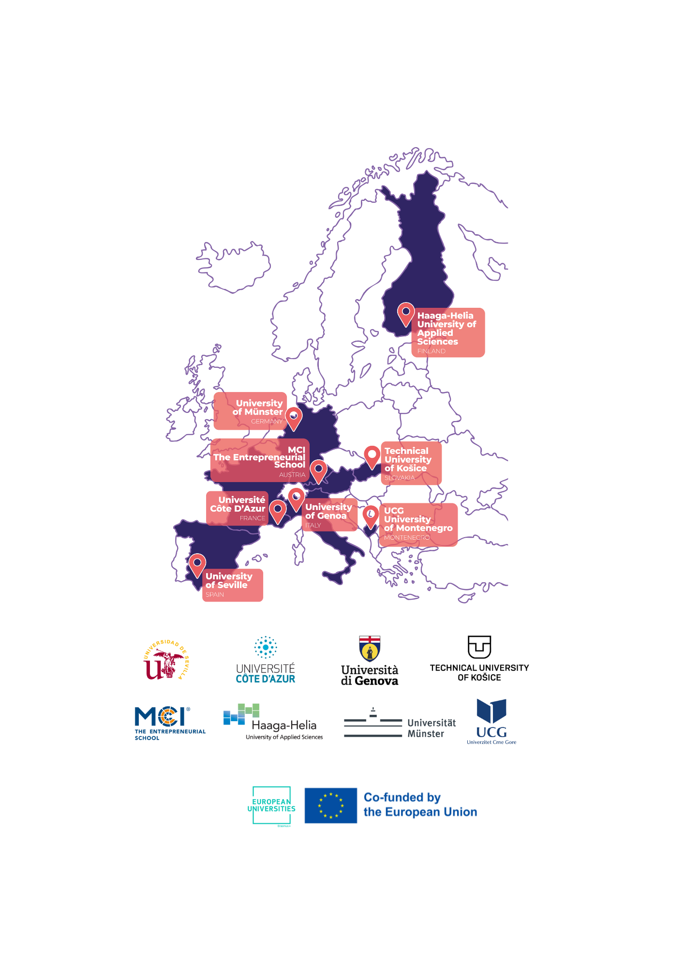

The Ulysseus Action has received funding from the European Union’s Erasmus + Programme under the grant agreement No 101124733. The views and opinions expressed in this communication are the sole responsibility of the authors and do not necessarily reflect the views of the European Commission

